**APPLICATION DEVELOPMENT CONCEPT PROPOSAL BASED ON THE (GRASPS) MODEL**

**Mental Health & Well-being Support App**

**Goals**

The app is designed to serve vulnerable and underserved populations who lack access to mental health care due to financial, social, or geographical barriers.

**Roles**

I am a mobile/web app developer

**Audiences**

Financially disadvantaged, youth/students, refugees/displaced, high-stress professionals, LGBTQ+, elderly, PWDs, and Mentally/Emotionally Unstable individuals.

**Situation**

The Mental Health & Well-being Support App aims to make mental health care more accessible and effective, particularly for underserved and vulnerable populations. By leveraging AI, anonymous support, and low-tech solutions, it addresses key barriers like stigma, limited access to services, and geographic isolation. This innovative approach helps improve mental health awareness, support, and resilience, contributing to the achievement of global health and peace goals. Ultimately, the app provides a scalable, inclusive solution to a pressing global issue.

**Products/Performance/Output**

**1) Objective**

The **Mental Health & Well-being Support App** aims to provide accessible, affordable mental health support to underserved populations, aligning with **SDG 3 (Good Health & Well-being)** and **SDG 16 (Peace, Justice & Strong Institutions)**. It focuses on reducing mental health disparities through anonymous counseling, self-help tools, and crisis intervention, while also improving awareness and destigmatizing mental health issues, particularly in areas with limited healthcare access. The app offers AI-driven, culturally sensitive support, especially for those in remote or conflict-affected regions.

**2) Key SDGs Targeted**

The **Mental Health & Well-being Support App** focuses on **SDG 3 (Good Health & Well-being)** by providing accessible mental health support, particularly in underserved areas, and promoting overall well-being. It aligns with **SDG 16 (Peace, Justice & Strong Institutions)** by fostering peace and stability in conflict zones through mental resilience. The app also supports **SDG 10 (Reduced Inequality)** by offering inclusive, culturally sensitive resources for marginalized populations. Additionally, it contributes to **SDG 9 (Industry, Innovation & Infrastructure)** by utilizing AI technology to innovate in mental health care, particularly in low-resource settings.

**3) Key Features**

The **Mental Health & Well-being Support App** offers the following key features:

* **AI-Powered Chatbot**: Provides 24/7 emotional support and self-guided therapy using natural language processing (NLP).
* **Anonymous Therapy & Peer Support**: Connects users with certified therapists or trained volunteers and includes peer support groups.
* **Guided Meditation**: Offers mindfulness exercises, breathing techniques, and guided meditations for stress and anxiety.
* **Mental Health Assessment & Self-Help Resources**: Features self-assessment tools and personalized self-help plans.
* **Crisis Support & Suicide Prevention**: Includes a one-tap SOS button for emergency crisis helplines and immediate support.
* **Offline & Low-Bandwidth Access**: Provides resources for users with limited internet and SMS-based therapy options.
* **Multilingual & Culturally Adapted Content**: Supports multiple languages and adapts content to local cultures to reduce stigma.

**4) Technical Architecture**

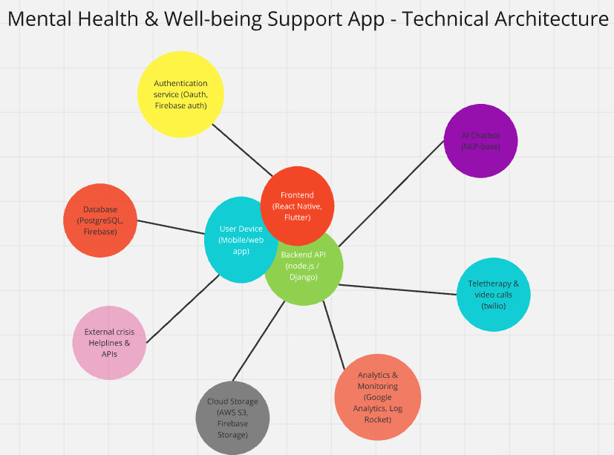

The figure above shows the diagram for my Mental Health & Well-being Support App. (Made using **Miro.com**)

**5) Research and Evidence**

The app is based on extensive research linking **mental health interventions** to **SDG 3 and SDG 16**:

**Mental Health and SDG 3: Good Health & Well-being**

* The **World Health Organization (WHO)** highlights mental health as **crucial** to overall well-being. [WHO Mental Health Action Plan 2013-2030](https://www.who.int/publications/i/item/9789240031029)
* Digital interventions have been proven to **increase accessibility to mental health services**, especially in low-resource settings. (Research by The Lancet Digital Health, 2021)

**Mental Health and SDG 16: Peace, Justice & Strong Institutions**

* The **United Nations Human Rights Council (UNHRC)** states that **mental health support is essential for conflict-affected populations**. (UNHRC Report on Mental Health & Human Rights, 2020)
* Digital mental health solutions **reduce the risk of violence, crime, and social unrest** by promoting **psychological resilience**. (Research by the Journal of Peace Research, 2019)

**Technology & AI in Mental Health**

* Studies indicate that **AI-powered chatbots** improve engagement in mental health programs. [(Harvard Medical School, 2022)](https://hms.harvard.edu/news/digital-mental-health)
* **Teletherapy and mobile apps** have been effective in **reducing depressive symptoms**. [(National Institute of Mental Health, 2021)](https://www.nimh.nih.gov/health/topics/technology-and-mental-health)